Mario Montessori remembered his mother telling this story and shared it in the December 1958 issue of the AMI’s Communications. He described it as a “cosmic tale” that she told to the children.
This story should be told in one sitting within the first week of the student’s arrival in the elementary classroom.
God Who Has No Hands
From the very beginning people have been aware of God. They could feel Him though they could not see Him, and they were always asking in their different languages who He was and where He was to be found.
"Who is God?" they asked their wise men.
"He's the most perfect of beings," was the answer.
"But what does He look like? Does He have a body like us?"
"No, He has not got a body. He has no eyes to see with, no hands to work with and no feet to walk with, but He sees everything and knows everything, even our most secret thoughts."
"And where is He?"
He is in heaven and on this earth. He is everywhere."
"What can he do?"
"Whatever He wishes."
"But what has God actually done?"
"What He has done is all that has ever happened. He is the Creator and Master Who has made everything, and all things He has made obey His will. He cares and provides for them all, and keeps the whole of His creation in the most wonderful harmony and order.
In the beginning there was only God. Since He was completely perfect and completely happy, there was nothing He needed. Yet out of His goodness He chose to create and all the He willed came into being; the heavens and the earth, all that is visible, and all that is invisible. One after another He made the light, the stars, the sky, and the earth with its plants and animals. Last of all He made man. Man, like the animals, was made out of particles of the earth, but God made him different from the animals and like Himself, for into his body which would die He breathed a soul which would never die."
Many people thought this was just a tale. How could someone with no eyes and no hands make things? If God is a spirit who cannot be seen or touched or heard, how could He have made the stars that sparkle overhead, the sea which is always astir, the sun, the mountains, and the wind? How could a spirit make the birds and fishes and trees, the flowers and the scent they shed around them? Perhaps He could make invisible things, but how could He make the visible world? It is all very well, they thought, to say that God is everywhere, but who has set their eyes on Him? How can we be sure He is everywhere? They tell He is the Master whom everybody and everything obeys, but why on earth should we believe that?
And it really does seem impossible. We who have hands could not do these things, so how could someone who has no hands do them? And can we imagine animals and plants and rocks obeying God? The animals do not understand when we talk to them, so how could they be obedient? Or the winds and the sea and the mountains? You can shout and scream and wave your arms at them, but they cannot hear you for they are not even alive, and they certainly won't obey you.
Yes, that is how it seems to us. But, as you will see, everything that exists, whether it has life or not, in all that it does and by the very fact of its being there, actually obeys the will of God.
God's creatures do not know that they are obeying. Those that are inanimate just go on existing. Those that have life move and go on living. Yet every time a cool wind brushes your cheek, its voice, if we could hear it, is saying: 'Lord, I obey.' When the sun rises in the morning and colors the glittering sea, the sun and the sunbeams are whispering, 'My Lord, I obey.' And when you see a bird on the wing, or fruit falling from a tree, or a butterfly hovering over a flower, the birds and their flight, the tree and the fruit and its fall to the ground, the butterfly and the flower and its fragrance are all repeating the same words: 'I hear, my Lord, and I obey.'
At first there was chaos and darkness was on the face of the deep. God said: 'Let there be light', and there was light. Before that there was only the deep, an immensity of space with no beginning and no end, indescribably dark and cold. Who can imagine that immensity, that dark and coldness?
When we think of dark, we think of night; but our night would be like brilliant sunshine in comparison with that darkness. When we think of cold, we think of ice. But ice is positively hot if you compare it with the coldness of space, the space that separates the stars: as hot, you might say, as a blazing furnace from which no heat can escape. In this measureless void of cold and darkness light was created. There appeared something like a vast, fiery cloud which included all the stars that are in the sky. The whole universe was in that cloud, and among the tiniest of stars was our own world; but they were not stars then; as yet there was nothing except light and heat. So intense was the heat that all the substances we know - iron, gold, earth, rocks, water - existed as gasses, as insubstantial as the air. All these substances, all the materials of which the earth and the stars are composed, wer fused together in one vast, flaming intensity of light and heat - a heat which would make our sun today feel like a piece of ice.
This raging fiery cloud of nothingness, to huge to imagine, moved in the immensity of freezing space, which was also nothingness, but infinitely vaster. The fiery mass was no bigger that a drop of water in the ocean of space, but that drop contained the earth and all the stars.
As this cloud of light and heat moved through empty space little drops fell from it. If you swing the water out of a glass, some of it holds together and the rest breaks up into separate drops. The countless hosts of stars are like these little drops, only instead of falling they are constantly moving round in space, in such a way that they can never meet. They are millions of miles from each other.
Indeed, some stars are so far away from us that it takes millions of years for their light to reach us. Do you know how fast light travels? (the children might answer: 100 mph, 200mph...?) No, much faster. It travels 186,000 - not per hour, but per SECOND. Imagine how fast that is! It means that in one second it can travel 7 times around the whole world. And do you know how big the world is? If we were to drive at 100 mph continuously, all day long and all night long, without stopping, it would take us more than 10 days to cover that distance. And yet the light covers it 7 times in one second! You 'click' with your fingertips, and it has gone around the earth 7 times already!
So, you can imagine how far some of these stars are, that it takes their light 1 million years to reach us?
Then there are so many stars that scientists have calculated that if each of them were a grain of sand, all the stars together would cover up all the states from Virginia to New York up to the height of 200 meters! One of these stars, one of these grains of sand among those thousands of billions of grains of sand, is our sun, and one millionth part of this grain is our earth. An invisible speck of nothingness.
One wouldn't think so. The sun doesn't look so big. But that is because it is so far away. The light from it takes about 8 minutes to reach us and if we were to travel the same distance at 100 mph it would take us a little more than 106 years to reach the sun. In fact, the sun is one million times bigger than the earth. The sun is so big that just one of its flames could contain 22 earths.
(CHART 1A: Earth Compared to the Sun)
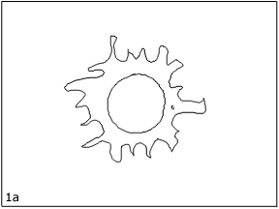
When God's will called the stars into being, there was no detail He had not planned. Every scrap of the universe, every speck which we might think too tiny to matter, was given a set of rules to follow. To the little particles which were like smoke, like vapor - which could only be distinguished as light and heat - moving at a fantastic speed he said: 'As you become cold you shall come closer and become smaller.'
And so, as they cooled they moved more and more slowly, clinging closer and closer to each other and occupying less and less space. The particles assumed different states which man called the solid, the liquid, or the gaseous state.
(DEMONSTRATION: Three States of Matter)
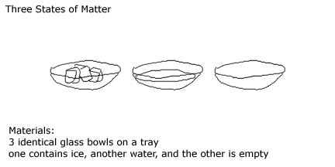
Everything we know is either a gas, a liquid, or a solid, and which of the three states it is at the moment depends on how hot or cold it is.
Then God gave some other instructions. Each of the tiny little particles was given a special love for certain particles and a special dislike for certain others. Some were attracted to each other and some were not. Just like human beings, they like some, and refuse to have anything to do with others. So they form themselves into different groups.
(DEMONSTRATION: Forces of Attraction)
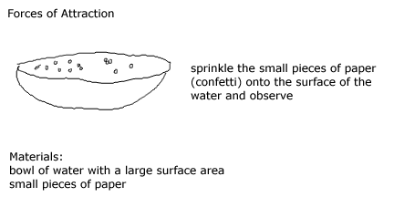
In this way, the particles combined and formed themselves into different groups.
In the solid state, God has made the particles cling so closely together that they are almost impossible to separate. They form a body which will not alter its shape unless one applies force. If a piece is broken off, the particles will still cling together. If, for instance, you start chipping a flint, the flint and the chips still remain solid pieces of stone.
When it came to liquids, God said: 'You shall hold together also, but not so very closely, so that you will have no shape of your own and will roll over each other.'
(DEMONSTRATION: Model of a Liquid)
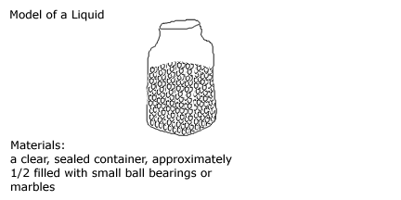
'Thus you shall flow and spread, filling every hollow, every crevice in your path. You will push downward and sideways, but never upwards.' That is why, though we can put our hands in water, we cannot put them inside a rock.
And to the gasses He said: 'Your particles shall not cling together at all. They can move freely in all directions.'
But as the particles were all so different individuals, they did not become solid or liquid or gas all at the same time. At certain temperature some remained solid, others became liquid and still others became gaseous.
(DEMONSTRATION: State of Matter and Heat)
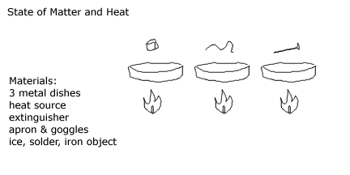
And so, while obeying these laws, the little drop of nothingness that was to become our world, the blazing mass, went on spinning and spinning around itself and around the sun in the tremendous cold of space.
And as time went on, the outer ring of this mass began a dance, the dance of the elements. The particles that were at the outermost edge became cold and shrank. Huddling together they hurried to the earth, but as soon as they approached the hotter part, they became hot and up they went again. Like little angels, they carried a bucket of hot, burning coal into space, and returned with some ice.
(CHART 3A: The Dance of the Elements)
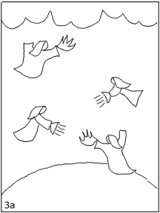
How marvelous it is! And how simple! If you become hot you expand and as you expand, you become lighter and soar upwards, like a bubble of air in the water. But, if you become cold, you shrink and fall as a grain of sand sinks to the bottom of a pond.
Because of this law the earth gradually changed from a ball of fire to the earth we know. This was the law that the tiny radiant particles obeyed as they danced their dance; particles to minute to be seen or even imagined, yet numerous enough to have produced the world.
For hundreds, thousands, millions of years this dance went on. Finally, the particles settled down, like tired dancers, and one after the other, they became first liquid and then solid and as they became liquid or solid some of them joined others to which they were attracted, forming new substances.
The heavier ones went nearer to the heart of the earth and the lighter ones floated above them like oil floating on the water.
(DEMONSTRATION: Liquids Settle According to Their Weight)
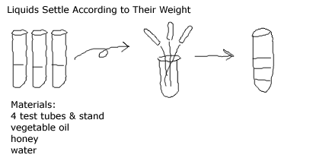
A thin scum was formed, like the skin which forms on milk when it is boiled and left to cool. It seemed as though the earth had taken some shape. But the elements inside this skin were still very hot. They felt trapped. They wanted to get out. What could they do otherwise? They had to follow the law of God: 'If you are hot, you expand.' There was no place to expand and so they burst out. They broke the skin and it was like a terrible fight.
(DEMONSTRATION: Volcano)
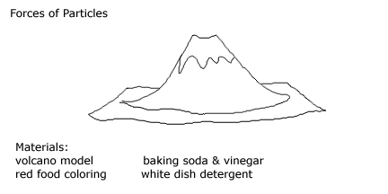
The water that formed on the surface turned immediately into vapor and went up as the hot stuff came out from inside the earth.
(CHART 4A: Volcanoes and Cloud)
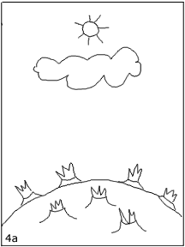
There were also ashes. A veil of clouds was drawn to cover the earth so that nobody could see what was going on. The sun was ashamed of them!
Eventually, the fighting ceased. As everybody cooled down, more and more gasses became liquid, more and more liquids became solids. The earth itself shrank and became wrinkled like an old apple that has been left in a cupboard. The wrinkles are mountains and the hollows are the oceans.
For, as the rocks had cooled down, water was able to return to the earth and it rained and rained. And the water, being liquid, filled every hollow and crevice found in its path. Thus the oceans were formed. Above them was the air, the air that we breathe. The cloud had disappeared.
(CHART 5A: Volcanoes and Water)
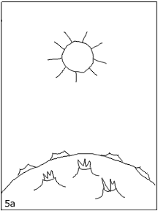
The veil had withdrawn and the sun could once again smile upon its beautiful daughter, the earth.
Rocks, water, air: solids, liquids, gasses. Today, as it was yesterday and millions of years ago, God's laws are obeyed in the same way. The world spins round itself and round and round the sun. And today, as it was millions of years ago, the earth and all the lements and compounds it ismade of, as they fulfill their tasks, whisper with one voice:
'Lord, Thy will be done; we obey.'"

